Nama : Nadia Salsabilla Imany
NIM : 12030123140310
Kelas : Pengkodean dan Pemrograman Kelas D

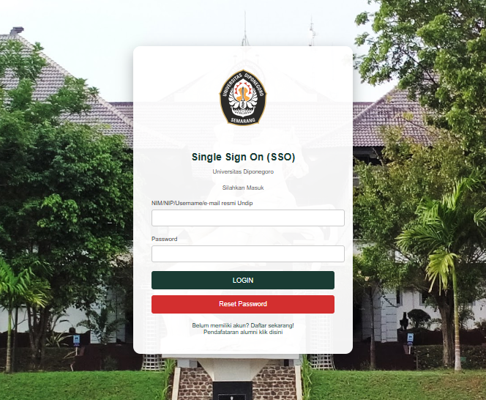
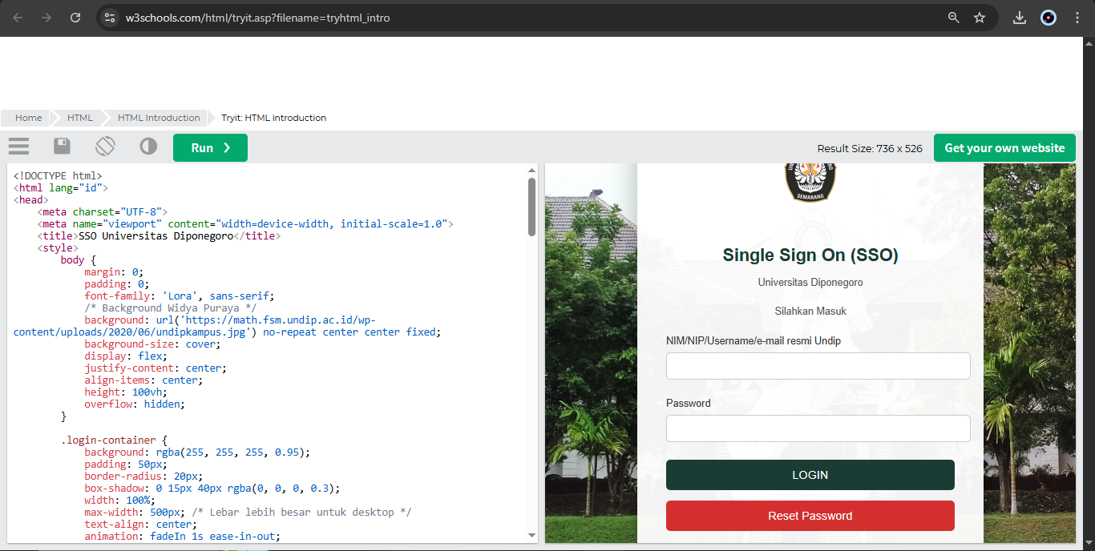
TUGAS 1: MEMBUAT TAMPILAN SSO LEBIH MENARIK MENGGUNAKAN W3SCHOOL
<!DOCTYPE html>
<html lang="id">
<head>
<meta charset="UTF-8">
<meta name="viewport" content="width=device-width, initial-scale=1.0">
<title>SSO Universitas Diponegoro</title>
<style>
body {
margin: 0;
padding: 0;
font-family: 'Lora', sans-serif;
/* Background Widya Puraya */
background: url('https://math.fsm.undip.ac.id/wp-content/uploads/2020/06/undipkampus.jpg') no-repeat center center fixed;
background-size: cover;
display: flex;
justify-content: center;
align-items: center;
height: 100vh;
overflow: hidden;
}

.login-container {
background: rgba(255, 255, 255, 0.95);
padding: 50px;
border-radius: 20px;
box-shadow: 0 15px 40px rgba(0, 0, 0, 0.3);
width: 100%;
max-width: 500px; /* Lebar lebih besar untuk desktop */
text-align: center;
animation: fadeIn 1s ease-in-out;
}

@keyframes fadeIn {
0% { opacity: 0; transform: translateY(-30px); }
100% { opacity: 1; transform: translateY(0); }
}

.logo {
width: 180px; /* Logo lebih besar untuk desktop */
margin-bottom: 30px;
}

h2 {
color: #1a3c34;
font-size: 28px; /* Judul lebih besar */
margin-bottom: 15px;
}

p {
color: #555;
font-size: 16px; /* Teks lebih besar */
margin-bottom: 25px;
}

.input-group {
margin-bottom: 25px;
text-align: left;
}

label {
display: block;
font-size: 16px; /* Label lebih besar */
color: #333;
margin-bottom: 8px;
}

input[type="text"],
input[type="password"] {
width: 100%;
padding: 12px; /* Input lebih besar */
border: 1px solid #ccc;
border-radius: 6px;
font-size: 16px;
transition: border-color 0.3s;
}

input[type="text"]:focus,
input[type="password"]:focus {
border-color: #1a3c34;
outline: none;
}

.login-btn {
background-color: #1a3c34;
color: white;
padding: 15px; /* Tombol lebih besar */
border: none;
border-radius: 6px;
width: 100%;
font-size: 18px; /* Teks tombol lebih besar */
cursor: pointer;
transition: background-color 0.3s;
}

.login-btn:hover {
background-color: #145c4f;
}

.reset-btn {
background-color: #d32f2f;
color: white;
padding: 15px;
border: none;
border-radius: 6px;
width: 100%;
font-size: 18px;
cursor: pointer;
margin-top: 15px;
transition: background-color 0.3s;
}

.reset-btn:hover {
background-color: #b71c1c;
}

.links {
margin-top: 25px;
font-size: 16px; /* Teks tautan lebih besar */
}

.links a {
color: #1a3c34;
text-decoration: none;
margin: 0 15px;
}

.links a:hover {
text-decoration: underline;
}

/* Media query untuk memastikan hanya desktop yang terpengaruh */
@media (max-width: 768px) {
.login-container {
max-width: 400px;
padding: 40px;
}

.logo {
width: 100px;
}

h2 {
font-size: 24px;
}

p, label, .links {
font-size: 14px;
}

input[type="text"],
input[type="password"] {
padding: 10px;
font-size: 14px;
}

.login-btn, .reset-btn {
padding: 12px;
font-size: 16px;
}
}
</style>
</head>
<body>
<div class="login-container">
<img src="https://upload.wikimedia.org/wikipedia/id/9/9b/UNDIPOfficial.png" alt="Logo Undip" class="logo">
<h2>Single Sign On (SSO)</h2>
<p>Universitas Diponegoro</p>
<p>Silahkan Masuk</p>
<form>
<div class="input-group">
<label for="username">NIM/NIP/Username/e-mail resmi Undip</label>
<input type="text" id="username" name="username" required>
</div>
<div class="input-group">
<label for="password">Password</label>
<input type="password" id="password" name="password" required>
</div>
<button type="submit" class="login-btn">LOGIN</button>
<button type="button" class="reset-btn">Reset Password</button>
</form>
<div class="links">
<a href="#">Belum memiliki akun? Daftar sekarang!</a><br>
<a href="#">Pendafataran alumni klik disini</a>
</div>
</div>
</body>
</html>

